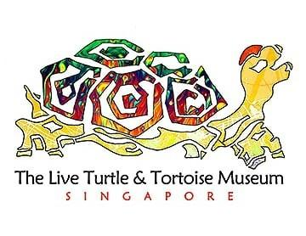

THE LIVE TURTLE AND TORTOISE MUSEUM TOUR BOOKING FORM

Dear Sir/ Mdm

Thank you for planning to organize a tour with us. The duration for the tour may vary from 50mins to 80mins. We have a limit of 80 pax per group, due to our shortage of staff. Here is the basic breakdown for the tour itinerary;
- A guided description of the different species of Turtles/Tortoise/Terrapins we have in the museum
- Learning the differences both physically and the behavior of Turtles / Tortoises / Terrapins. Vegetables feeding for the tortoises.
- Bathing of Giant Tortoise (>25pax, Depending on the circumstances of the group, and if weather permits)
- Terrapin Pond Feeding
- Viewing of collected artefacts from all around the world related to Turtles.
Please do update us if you’re interested with the form on the next page, and email it to us at enquiries@turtle-tortoise.com if you have any queries don’t hesitate to contact us!
Hope this information is helpful. Hope to hear from you soon, and have a nice day.

Best Regards
Team@LTTM

Company/Group Name | Enter Name here
Point of Contact | First Name Last Name
Contact No. | Enter Phone No. here
Email | Enter email address here
No. of LTTM members (If Applicable) | Enter no. of members here.
Date interested for Tour (if unavailable we will contact you) | Click here to enter a date. 10am ☐ 2pm ☐
Backup Date/2nd date (If Applicable) | Click here to enter a date. 10am ☐ 2pm ☐

Tour Packages
Group Size | Prices (regardless of age) | Please tick one | Please State No. of participants
Below 30 Pax | $20/pax | ☐ | No. of Pax
30-50 Pax | $14/pax | ☐ | No. of Pax
Above 50 Pax | $10/pax | ☐ | No. of Pax

+ Additional Options for Tour |  | Please Tick if interested | Please State No. of Participants
Souvenir (small hand painted turtle) | $2/pax | ☐ | No. of Pax
Turtle Race | $2/pax | ☐ | No. of Pax
Drawing Contest (Monthly selection) | $4/pax | ☐ | No. of Pax

Additional Requests or queries: Enter Queries here.

